|  |  |
| --- | --- |
| **Module name** | Login |

|  |  |
| --- | --- |
| **Test Case ID :** | TS1 |
| **Tester Name :** | Shani Tiwari |
| **Taste Case Description :** | To check login functionality of Code academy website |
| **Prerequisites :** | 1.Stable internet connection |
| 2.Browser(All) |
| **Tester's Name :** | Shani Tiwari |
| **Environmental Information :** | 1.OS: Windows/Linux/Mac |
| 2.System: Laptop/Desktop |

1. Case ID 1 :-

* Checking that after entering the correct username & password, the user can login

|  |  |  |  |  |  |
| --- | --- | --- | --- | --- | --- |
| **Test Steps** | **Test Input** | **Expected Results** | **Actual Results** | **Status** | **Comments** |
| 1.Enter Username | Username: Myname | Welcome to our Code Acedemy! | Welcome to our Code Acedemy! | Pass | No Issues Found |
| 2.Enter Password | Password: Mypassword |  |  |  |  |
| 3.Click on login |  |  |  |  |  |

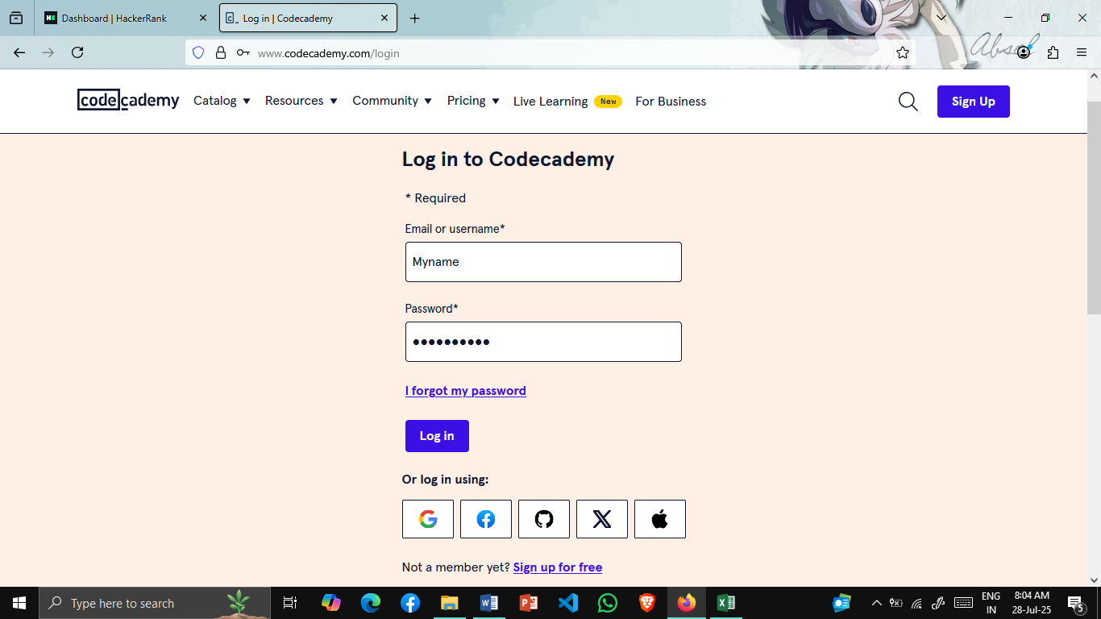

1. Case ID 2 :-

* Checking that after entering the incorrect username & password

|  |  |  |  |  |  |
| --- | --- | --- | --- | --- | --- |
| **Test Steps** | **Test Input** | **Expected Results** | **Actual Results** | **Status** | **Comments** |
| 1.Enter Username | Username: Notmyname | Invalid email or password | Invalid email or password | Pass | No Issues Found |
| 2.Enter Password | Password: Notmypassword |  |  |  |  |
| 3.Click on login |  |  |  |  |  |

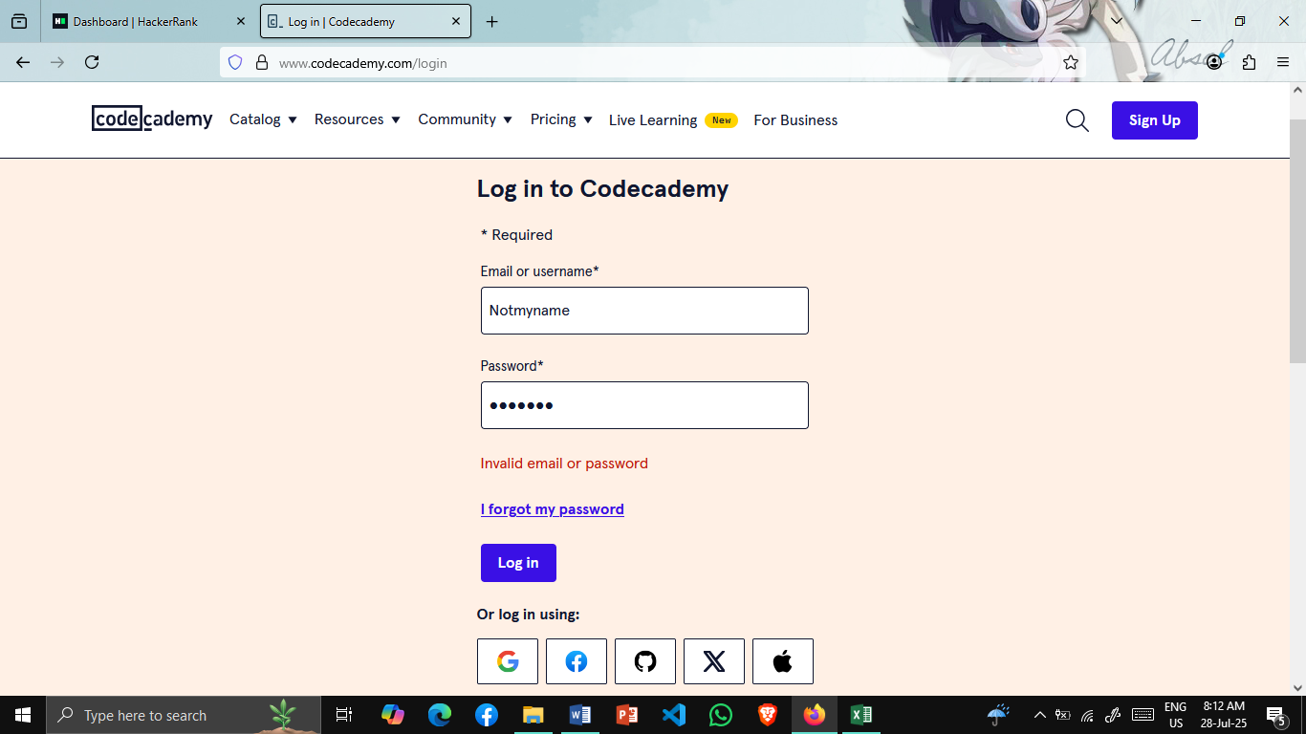

1. Case ID 3 :-

* Checking forgot password feature

|  |
| --- |
| **Test Steps** |
| 1.Click on I forgot my password |



|  |  |
| --- | --- |
| **Test Steps** | **Test Input** |
| 2.Please enter your email | [S@mymail.com](mailto:S@mymail.com) |

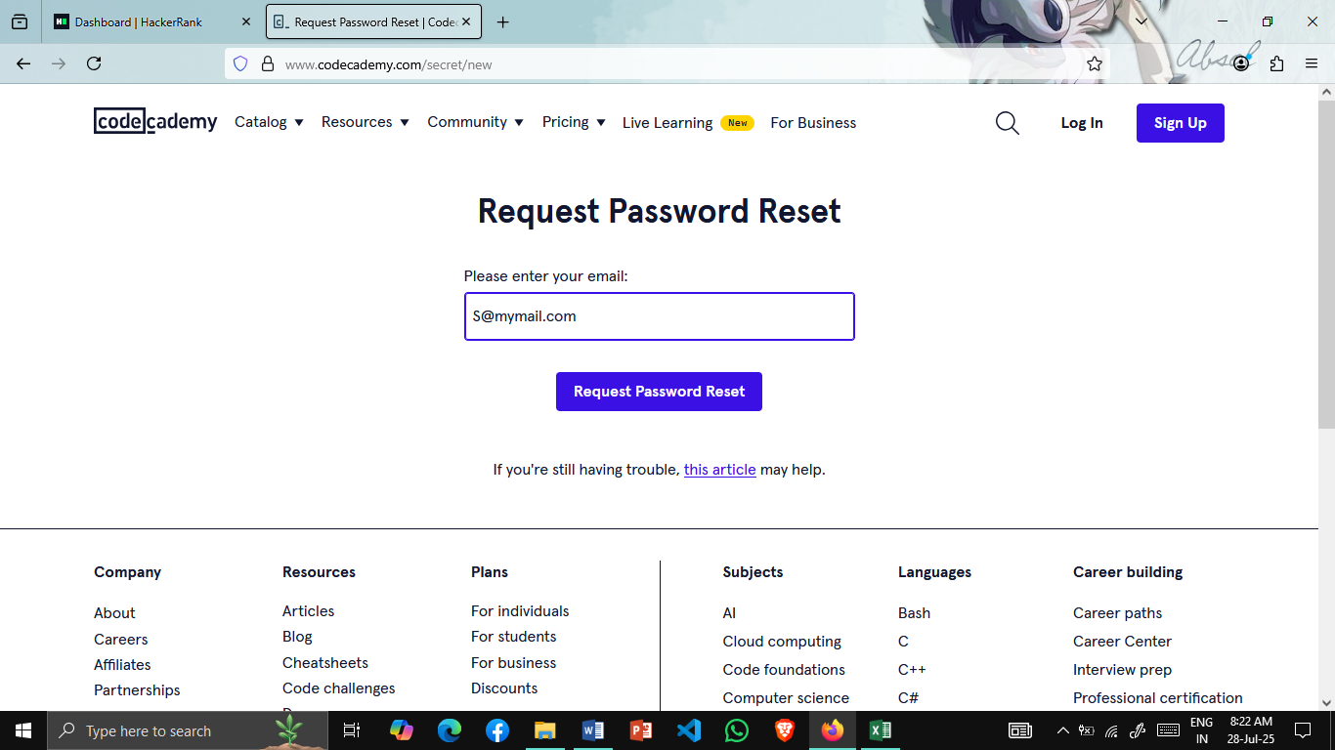

|  |
| --- |
| **Test Steps** |
| 3.Click on Request Password Reset |

|  |  |  |  |
| --- | --- | --- | --- |
| **Expected Results** | **Actual Results** | **Status** | **Comments** |
| Password Reset Sent | Password Reset Sent | Pass | No Issues Found |

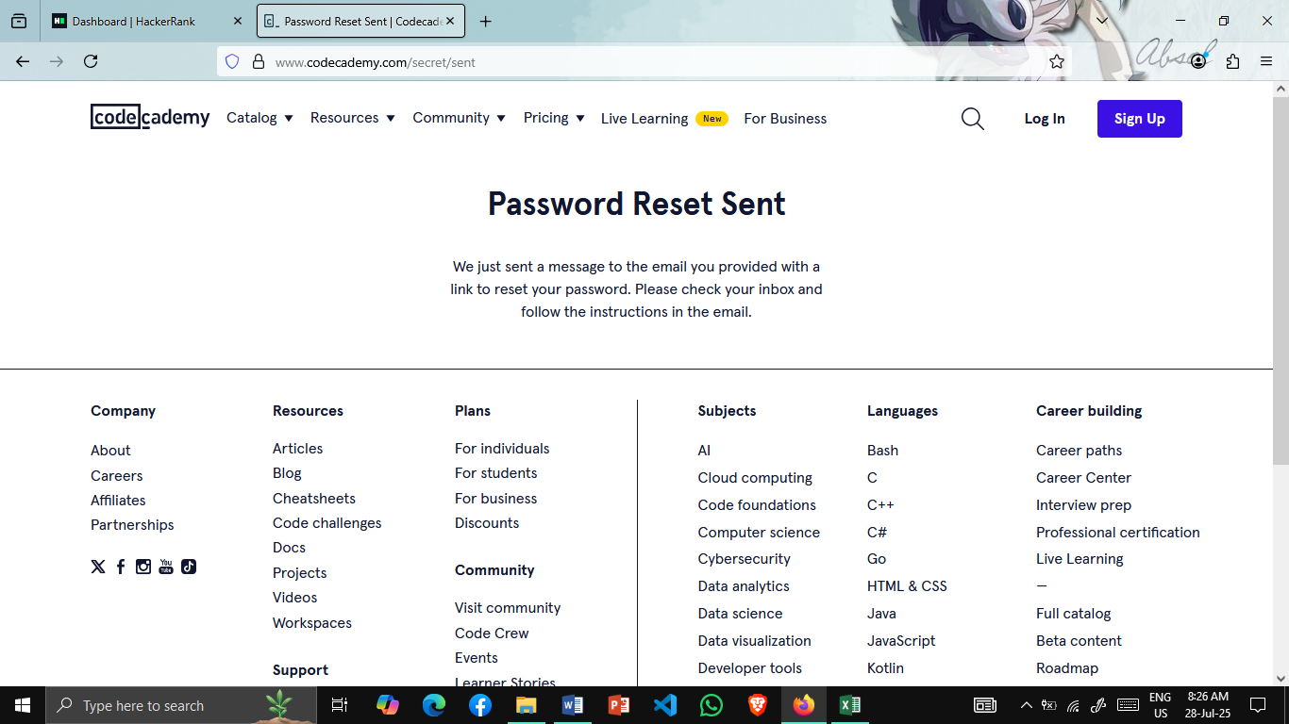

1. Case ID 4 :-

* Checking login using other media

|  |
| --- |
| **Test Steps** |
| 1.Click on your media logo |

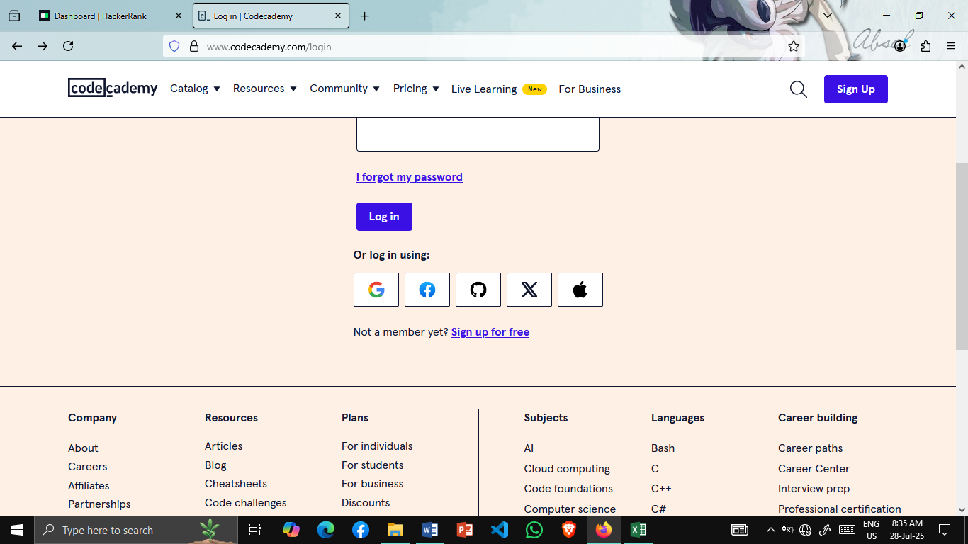

|  |
| --- |
| **Test Steps** |
| 2.Select Your Account |

